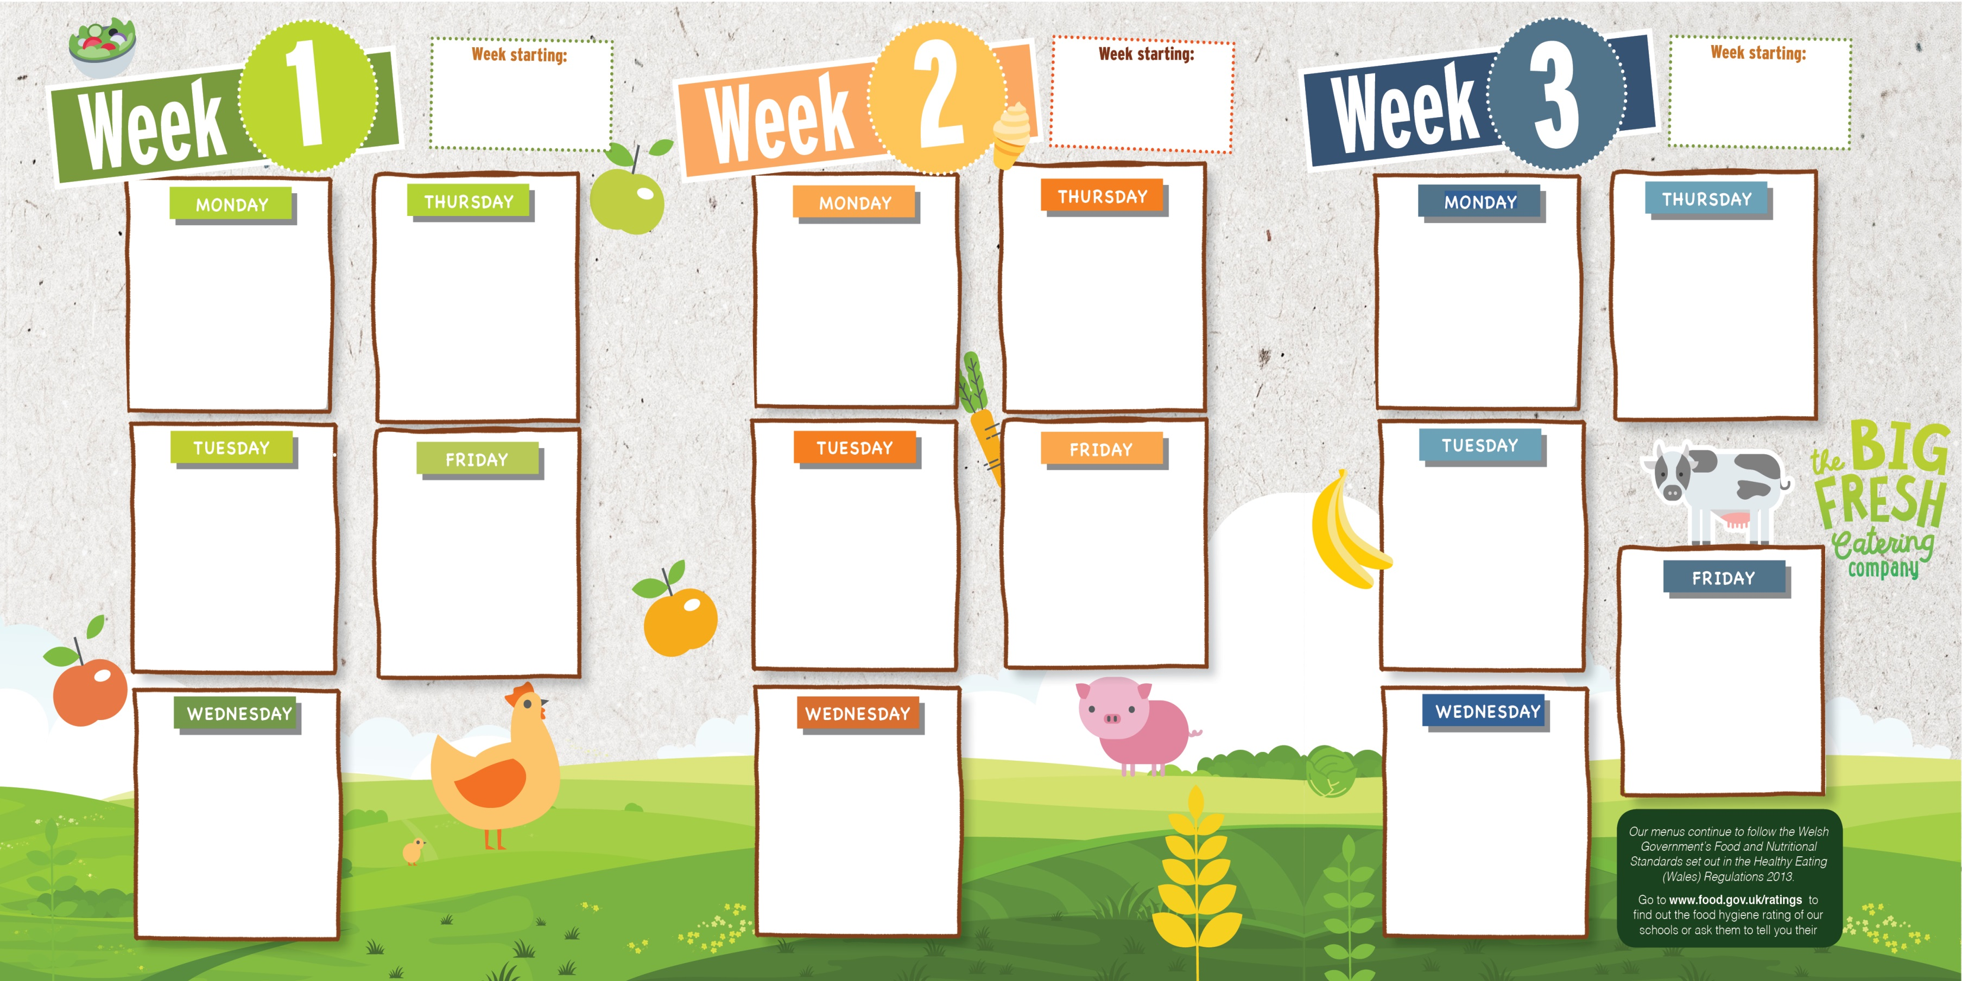
Homemade Margarita Pizza
Potato Wedges
Side Salad & Baked Beans
Fresh Fruit or Flap Jack & Fruit Slices

20/9/21, 11/10/21, 1/11/21 22/11/21, 13/12/21, 3/1/22
24/1/22, 14/2/22, 7/3/22 28/3/22

13/9/21, 4/10/21, 25/10/21, 15/11/21, 6/12/21, 27/12/21, 17/1/22, 7/2/22, 28/2/22,
21/3/22

6/9/21, 27/9/21, 18/10/21 8/11/21, 29/11/21, 20/12/21
10/1/22, 31/1/22, 21/2/22 14/3/22, 4/4/22

Oven Baked Battered Salmon Fillet
or Glamorgan Sausage
Jacket Wedges & Baked
Beans
Fresh Fruit or Homemade Apple Crumble with Custard
Juicy Meatballs in Gravy
or Vegetarian Meatballs in Gravy
Pasta, Broccoli & Carrots
Fresh Fruit or Homemade Ginger Cake with Custard
Homemade Pasta Bolognaise
or Vegetarian Bolognaise
& Carrots
Fresh Fruit or
Homemade Muffin with Custard
Oven Baked Battered Salmon Fillet
or Veggie Nuggets
Chipped Potatoes, Peas & Sweetcorn
Fresh Fruit or
Homemade Chocolate & Banana Sponge & Custard
All Day Breakfast
or Vegetarian All Day Breakfast
Baked Beans, Tomatoes Fresh Fruit or Homemade Muffin with Custard

Homemade Chicken Curry or Lentil Curry
Rice, Naan Bread & Seasonal Vegetables
Fresh Fruit or
Yoghurt
& Fruit Slices

Homemade Pasta Bolognaise
or Vegetarian Bolognaise
Peas & Sweetcorn
Fresh Fruit or
Cornflake Crisp
Reduced Fat Sausages or Vegetarian Sausages
Chipped Potatoes &
Peas
Fresh Fruit or Angel Delight & Fruit Slices

Homemade Cheese Wheels
Herby Diced Potatoes, Peas & Sweetcorn
Fresh Fruit or
Yoghurt & Fruit Slices
Roast Turkey
or Quorn Fillet
Stuffing, Roast & Mashed Potato, Green Vegetable Medley & Carrots
Fresh Fruit or
Ice Cream
Roast Pork Loin
or Glamorgan Sausage
Roast & Mashed Potato Stuffing, Carrot & Swede Mash, Broccoli
Fresh Fruit or Artic Roll & Fruit Slices
Fish Fingers
or Glamorgan Sausage
Smiley Faces &
Baked Beans
Fresh Fruit or
Homemade Hot Chocolate Pudding &
Vanilla Sauce
Succulent Roast Beef
or Quorn Fillet
Yorkshire Pudding, Roast & Mashed Potato, Green Vegetable Medley & Carrots
Fresh Fruit or
Ice Cream
Tomato & Basil Pasta Bake with Cheese
Crusty Bread, Peas, & Sweetcorn
Fresh Fruit or Yoghurt & Fruit Slices


Welcome to our menu
Allergen information to accompany this menu is provided to staff for distribution upon request
Please contact us if your child has specialist dietary needs; we aim to provide a healthy balanced school meal for every pupil. A carbohydrate count of the menu for our diabetic diners is also available from our website

www.bigfreshcatering.co.uk

